**Project Design Phase-II Data Flow Diagram & User Stories**

|  |  |
| --- | --- |
| Date | 15 November 2022 |
| Team ID | PNT2022TMID48496 |
| Project Name | Project – Smart Farmer - IOT Enabled Smart Farming Application |
| Maximum Marks | 4 Marks |

**Data Flow Diagrams:**

A Data Flow Diagram (DFD) is a traditional visual representation of the information flows within a system. A neat and clear DFD can depict the right amount of the system requirement graphically. It shows how data Enters and leaves the system, what changes the information, and where data is stored.

**Example:** [**(Simplified)**](https://developer.ibm.com/patterns/visualize-unstructured-text/)



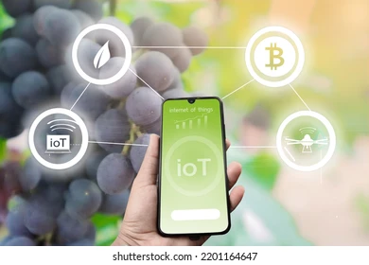

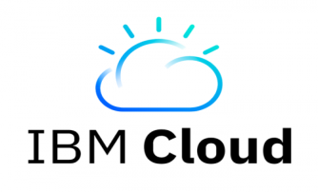

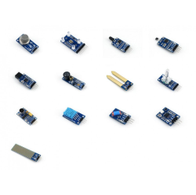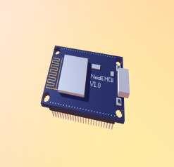

**SENSOR**

**Node MCU**

**User Stories**

Use the below template to list all the user stories for the product.

|  |  |  |  |  |  |  |
| --- | --- | --- | --- | --- | --- | --- |
| **User Type** | **Functional**  **Requirement (Epic)** | **User Story Number** | **User Story / Task** | **Acceptance criteria** | **Priority** | **Release** |
| Customer (Farmer) | Monitoring the sensors | USN-1 | As a user, I want to know about the data’s collected by the sensors. | I know the better knowledge about my field | High | Sprint-1 |
|  | Motor control | USN-2 | As a user, I want to turn on/off my motor when I am not in my land. | By controlling my motor, I can access from any place. | High | Sprint-1 |
|  | Moisture Level | USN-3 | As a user, I want to know the moisture level in my land | I can take decision whether  to water the field based on  the moisture level detection. | High | Sprint-2 |
|  | Temperature Level | USN-4 | As a user, I want to know the temperature Level in my land | I can take decision whether to water the field based on the temperature level detection. | High | Sprint-2 |
| Houseplant | API call for permission | USN-5 | As a user, I can give permission for the activation of the automated irrigation system. | Controlling automated irrigation system | High | Sprint - 1 |
| Customer (Farming ) | Monitoring large lands | USN-6 | As a user, I need to monitor my large land with live at all | I can monitor my large land even I not near to my field | High | Sprint -1 |